6:45 p.m. 4/17/19 I asked Wes on Zoom to look at my route design…he said it looked good, but the route buildout was a problem because it won’t run without errors. It will cause me lots of problems when I am working through it to get it fixed. So he made another real quick . Also see bottom for his comments on html file names

Wes showing a better skeleton

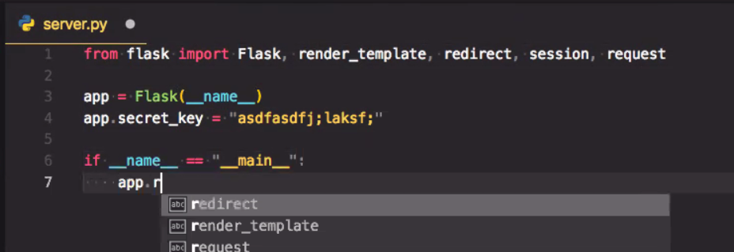

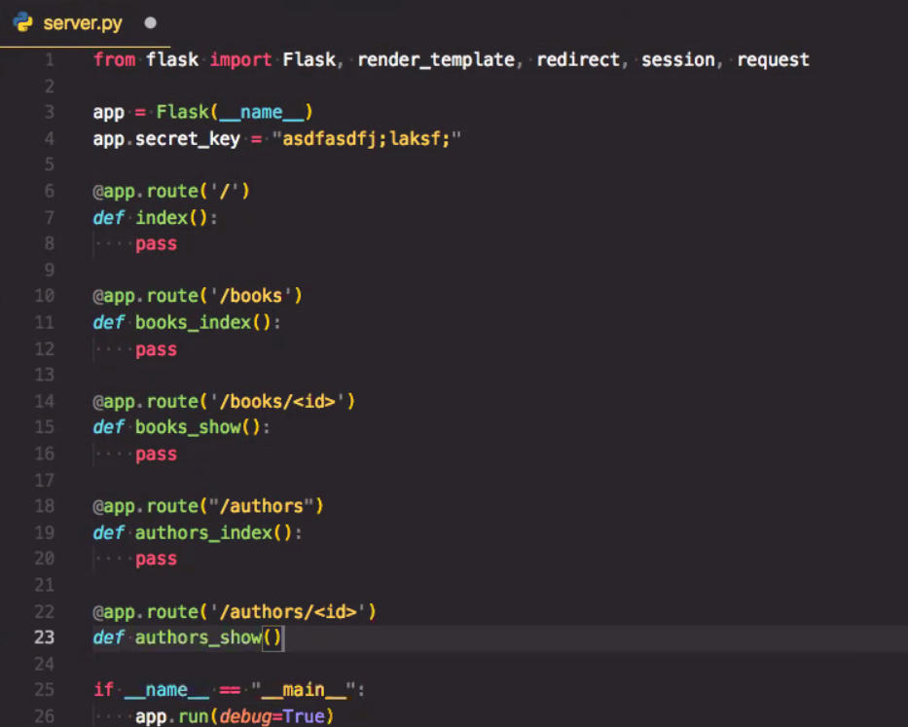

All of his will run from the start..it works from the start

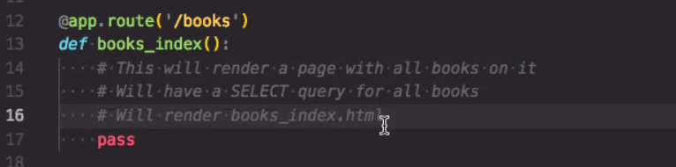

First step of whole thing is designing database…tables..etc..ERD

Pick out the routes from his Restful Routes page….look through it and ask: do I need one of those

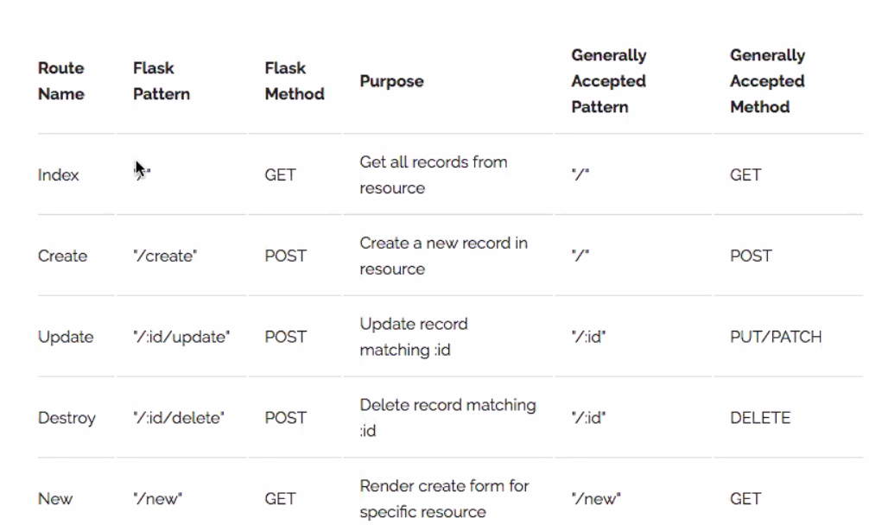

Go through the list asking: do I need one of these

Schema design should take 2030 minutes

Schema + wireframe should make the route design easy

-----------=============

File naming

He said

* the register_login page would typically be the index.html page…Me: the home page, or first place a user ends up
* #reglogPW.html is used for registration and login WH users_new
* #allBooks.html is used for displaying All books whether favorited or not This is a success page WH: call it books_index
* #oneBook.html displays single book WH: books_show

-----=

Timing: he said my route planning should be no more than 15 minutes….database design and build should be most of the time